Heart Disease Prediction Using
Machine Learning

Submitted by
Student name: Riyad Shikdar Arin
ID No: 221-0116-203

A Project Submitted in partial Fulfillment of the requirement for the Degree of Bachelor of Science in Computer Science and Engineering

Supervisor: Mahmudur Rahman Roni, Assistant Professor Dept of CSE



Atish Dipankar University of Science and Technology
September 2025

Declaration

In this project, in the name of almighty Allah. I would like to dedicate my lovely parents who had sacrificed a lot of happiness in their life for progressing me. Also, I would like to dedicate to my supervision Assistant Professor Mahmudur Rahman Roni, Department of CSE, ADUST. I also extend my gratitude to my all-department teacher. I will always appreciate all they have done, especially helping me develop my technological skills.

______________
Date: 11.09.2024 Riyad Shikdar Arin
ID No: 221-0116-203

Certificate

B.Sc. Project entitled:

“Heart Disease Prediction Using Machine Learning”

Under my supervision, meets acceptable presentation that is standard and can
be submitted for evaluation to the department of Computer Science and
Engineering in partial fulfillment of the requirement for the degree of Bachelor of
Science (B.Sc.) in Computer Science and Engineering.

______________
Date: 11.09.2024 Mahmudur Rahman Roni
Assistant Professor Dept of CSE

ACKNOWLEDGEMENTS

First and foremost, I would like to express my sincere gratitude to Almighty Allah for giving me the strength and patience to complete this thesis work.

I am deeply thankful to my supervisor and faculty members at the Department of Computer Science and Engineering for their continuous guidance, feedback, and encouragement throughout this research. Their expertise and support played a very important role in shaping this work.
I would also like to thank all the annotators who helped label the dataset used in this study. Their time and careful attention to the Bangla literary texts were essential to making this research possible.
Special thanks go to my family and friends for their constant moral support and encouragement during difficult times. Without their love and patience, this journey would have been much harder.
Finally, I would like to acknowledge the open-source communities and researchers whose prior work in natural language processing and machine learning has been an important foundation for this study.

ABSTRACT

The Bangla language is spoken by more than 265 million people around the world, making it one of the most widely used languages globally. Despite this, research in the field of Natural Language Processing (NLP) has mostly ignored Bangla, especially when it comes to understanding emotions in text. Most available tools and datasets for Bangla focus only on simple positive and negative sentiment labels, and they are based on social media content. Very little work has been done to identify more detailed and specific emotions in Bangla literature such as poems and song lyrics.
This thesis presents a complete study of multi-class emotion classification in Bangla literary text. We built a new dataset of more than 18,000 text samples collected from Bangla poems and song lyrics found on the internet. Each sample was labeled with one of seven emotion categories: Joy (আনন্দ), Sadness (দুঃখ), Anger (রাগ), Fear (ভয়), Love (ভালোবাসা), Surprise (বিস্ময়), and Patriotism (দেশপ্রেম). The emotion of Patriotism was especially included because it plays a very important and unique role in Bangla literary and cultural tradition.
We designed and tested a three-level modeling pipeline. The first level used classical machine learning classifiers such as Logistic Regression, Support Vector Machine, and Stochastic Gradient Descent on basic word-level features. The second level used improved features by combining both word-level and character-level patterns, along with an ensemble method called Biased Hybrid Stacking that was designed to handle the problem of unequal class sizes. The third level used BanglaBERT, which is a deep learning language model that was pre-trained specifically on large amounts of Bangla text.
Our results showed that the classical models achieved up to 63.06% accuracy, the hybrid ensemble improved this to 67.22% accuracy with 64.88% Macro F1 score, and BanglaBERT reached the highest performance at 72.32% accuracy with 70.89% Macro F1 score. The results clearly show that as we move from simple to more advanced models, the performance improves — especially for emotions that appear less frequently in the dataset. This work contributes a new large-scale Bangla emotion dataset, a thorough comparison of different modeling approaches, and valuable insights into the challenges of emotion classification in low-resource, literary Bangla text.

Keywords: Bangla NLP, Emotion Classification, BanglaBERT, Ensemble Learning, Low-Resource Language, Text Classification, Class Imbalance, Natural Language Processing

LIST OF FIGURES

Fig 3.1: Heart Disease Prediction Framework………………………………………...... | 14
Fig 3.2: Every column relationship with heart disease positive patients……………… | 16
Fig 3.3: Age category (Heart Disease patients)………………………………………… | 17
Fig 3.4: BMI of (Heart disease positive patients)………………………………………. | 17
Fig 3.5: K Fold Cross Validation………………………………………………………. | 29
Fig 3.6: Sigmoid Function……………………………………………………………… | 21
Fig 3.7: Decision Tree………………………………………………………………….. | 22
Fig 3.8: K-Nearest Neighbors (KNN)………………………………………………….. | 23
Fig 3.9: Random Forest………………………………………………………………. | 23
Fig 3.10 Model Deployment Workflow……………………………………………….. | 25
Fig 3.11 Web Interface…………………………………………………………………. | 26
Fig 4.1: Model’s Accuracy…………………………………………………………….. | 27
Fig 4.2: Precision, recall, F1-Score For class 0………………………………………….. | 28
Fig 4.3: Precision, recall, F1-Score For class 1………………………………………….. | 29
Fig 4.4: Logistic Regression Accuracy, Precision,Recall,Confusion Matrix…………… | 30
Fig 4.5: Random Forest Accuracy, Precision,Recall,Confusion Matrix………………… | 31
Fig 4.6: Decision Tree Accuracy, Precision,Recall,Confusion Matrix………………….. | 32
Fig 4.7: KNN Accuracy, Precision,Recall,Confusion Matrix…………………………... | 33
Fig 4.8: XGBoost Accuracy, Precision,Recall,Confusion Matrix………………………. | 34

LIST OF TABLE
3.1 Dataset Description…………………………………………………………. | 15
3.2. Comparison between before and after SMOTETomek……………………. | 18
3.3 Table Train-Test Split………………………………………………………. | 18
4.1 Accuracy, Precision, Recall, F1-Score for class 0………………………….. | 35
4.2 Accuracy, Precision, Recall, F1-Score for class 1………………………….. | 35

LIST OF ABBREVIATIONS

XGB Extreme Gradient Boosting
KNN K-Nearest Neighbors

TABLE OF CONTENTS
DECLARATION………………………………………………………………………  CERTIFICATE …………………………………………………………………….....  ACKNOWLEDGEMENTS …………………………………………………………..  ABSTRACT…………………………………………………………………………...  LIST OF FIGURES …………………………………………………………………...  LIST OF ABBREVIATIONS ………………………………………………………...  LIST OF FIGURES …………………………………………………………………... | 2  3  4  5  6  7  7

CHAPTER
I.INTRODUCTION:…………...…………………………………………….…....  1.1 Overview …………………………………………………………………….....  1.2 Motivation………………………………….……….…………………………..  1.4 Research Outline: ……………………………………………............................ | 10  10  10  11

II. BACKGROUND STUDY:………………………………………………………. | 12
2.1 Conceptual Study……………………………………………………………….. | 12

III. METHODOLOGY:……………………………………………………………. | 14
3.1 Introduction…………………………………………………………………... | 14
3.1.1 Data Collection………………………………………………………………. | 17
3.1.2 Data Preprocessing…………………………………………………………… | 18
3.2.1 Model Building………………………………………………………………. | 18
3.2.2 Model Training………………………………………………………………. | 19
3.2.3 K-Fold Cross-Validation…………………………………………………….. | 19
3.2.4 Ethical Consideration………………………………………………………... | 20
3.2.5 Software and Tools………………………………………………………….. | 20
3.3.1 Logistic Regression Algorithm……………………………………………… | 21
3.3.2 Decision Tree Algorithm…………………………….………………………. | 22
3.3.3 K-Nearest Neighbor Algorithm……………………………………………… | 23
3.3.4 Random Forest Algorithm…………………………………………………… | 23
3.3.5 XGBoost Algorithm…………………………………………………………. | 24
3.4 Model Evaluation……………………………………………………………. | 24
3.5 Model Deployment…………………………………………………………... | 25

IV. PERFORMANCE ANALYSIS……………………………………………….. | 27
4.1 Result & Discussion…………………………………………………………….. | 27
4.2 Accuracy and Results for Logistic Regression………………………………….. | 30
4.3 Accuracy and Results for Random Forest……………………………………….. | 31
4.4 Accuracy and Results for Decision Tree………………………………………… | 32
4.5 Accuracy and Results for K-nearest neighbors………………………………….. | 33
4.6 Accuracy and Results for XGBoost………….………………………………….. | 34
4.7 Accuracy and Results for All Model…………………………………………………….. | 35
4.8 Comparetive Analysis…………………………………………………………… | 35

V. CONCLUSION………………………………………………………………… | 37
5.1 Conclusion……………………………………………………………………… | 37
5.2 Future work……………………………………………………………………... | 37

References ……………..….……………………………..………………….....…..…39

CHAPTER I

INTRODUCTION
1.1 Background and Motivation

Language is one of the most important ways in which human beings express their thoughts, feelings, and ideas. Over many centuries, poets, writers, and songwriters have used language to convey deep human emotions such as love, grief, joy, anger, and patriotism. In today's digital world, there is an enormous amount of text available on the internet — from social media posts and news articles to books, poems, and song lyrics. Natural Language Processing (NLP) is the branch of computer science and artificial intelligence that deals with teaching computers to understand and work with human language.
One of the most interesting and important problems in NLP is emotion classification — the task of automatically identifying what kind of emotion is present in a piece of text. This has many useful applications in real life. For example, companies can use emotion analysis to understand how customers feel about their products. Governments and health organizations can monitor public emotion during times of crisis. Music streaming services can recommend songs based on the listener's emotional state.
The Bangla language, also known as Bengali, is spoken by more than 265 million people around the world. It is the official language of Bangladesh and one of the official languages of India (especially in the state of West Bengal). Bangla is the seventh most spoken language in the world by number of native speakers. Despite its large global community of speakers, Bangla remains what researchers call a 'low-resource language' in the context of NLP. This means that there are not many annotated datasets, pre-trained models, or computational tools available for Bangla compared to languages like English, French, or Spanish.
The Bangla literary tradition is among the richest in South Asia. Great literary figures like Rabindranath Tagore, who won the Nobel Prize for Literature in 1913, and Kazi Nazrul Islam, the national poet of Bangladesh, have produced thousands of poems and songs that carry deep emotional content. These works explore the entire range of human emotion — from the joy of spring and the pain of separation to the fierce pride in one's homeland. Yet, very little computational research has been done to analyze and classify the emotions present in this rich body of literature.
This thesis is motivated by the need to bridge this gap. We believe that by building better tools for understanding emotion in Bangla text, we can make NLP more useful for the millions of Bangla-speaking people around the world, while also preserving and celebrating the beauty of Z

1.2 Problem Statement
Most existing research on emotion analysis in Bangla focuses on social media text and uses a very simple two-class setup — classifying text as either 'positive' or 'negative.' While this binary approach is useful in some cases, it is far too limited for literary text. A poem can express sadness and love at the same time. A song can carry both anger and patriotism. Reducing these complex emotions to just two categories means losing a lot of meaningful information.
Furthermore, almost no work has been done on building large-scale, multi-class emotion datasets from Bangla poems and song lyrics. Existing datasets for Bangla NLP are small, often covering only two or three emotion categories, and they do not include emotions that are culturally specific to the Bangla tradition, such as Patriotism (দেশপ্রেম). The emotion of patriotism holds a special place in Bangla literature and music — especially in songs and poems written during the Liberation War of Bangladesh in 1971. Ignoring this emotion means missing a culturally crucial part of the Bangla emotional landscape.
Additionally, there is a technical problem known as class imbalance — in any real dataset, some emotions appear much more often than others. For example, sadness and love are common themes in Bangla poetry, while surprise and patriotism appear less often. Most machine learning models tend to focus on the frequent emotions and ignore the rare ones, which leads to poor performance for minority classes. This is a serious challenge that needs to be addressed carefully.
1.3 Research Objectives
This thesis has the following specific research objectives:

- To build a large-scale, high-quality dataset of Bangla poems and song lyrics labeled with seven emotion categories: Joy, Sadness, Anger, Fear, Love, Surprise, and Patriotism.
- To design and evaluate a three-level pipeline of machine learning models — from simple classical methods to advanced deep learning transformers — for multi-class emotion classification.
- To investigate the effect of different feature engineering strategies on classification performance, including word-level and character-level TF-IDF features.
- To address the class imbalance problem using class-weighted loss functions and ensemble methods.
- To compare all approaches systematically using standard evaluation metrics and to identify the strengths and weaknesses of each method for different emotion classes.

1.4 Research Contributions
This thesis makes three original contributions to the field of Bangla NLP and emotion analysis:
- A new annotated dataset of more than 18,000 Bangla text samples from poems and song lyrics, labeled across seven emotion categories. This is, to the best of our knowledge, the largest multi-class Bangla emotion dataset from literary sources. The inclusion of the Patriotism class makes this dataset culturally unique.
- A systematic three-tier comparative study of machine learning approaches: classical baselines (Logistic Regression, SVM, SGD), a hybrid stacking ensemble with enriched features and class-weighted loss, and a fine-tuned BanglaBERT transformer. This provides a clear view of how each level of complexity contributes to performance improvement.
- A detailed per-class analysis of model performance, revealing exactly which emotions are well-handled and which remain challenging for each type of model. This analysis provides useful insights for future research on minority class handling and emotion-specific feature design.
1.5 Thesis Organization
The remainder of this thesis is organized as follows. Chapter 2 presents a review of related work in sentiment and emotion analysis, Bangla NLP, ensemble learning, and transformer models. Chapter 3 describes the process of dataset construction, including data collection, annotation, and preprocessing. Chapter 4 explains the methodology for all three modeling tiers. Chapter 5 presents the experimental results and discusses the findings in detail. Chapter 6 concludes the thesis and suggests directions for future research. Finally, the References section lists all sources cited in this work.

CHAPTER II

Literature Review

This chapter reviews prior research that is relevant to our work. We examine studies on sentiment and emotion analysis (especially in low-resource languages), work specifically on Bangla NLP, ensemble methods for text classification, and deep learning approaches using transformers.

2.1 Sentiment and Emotion Analysis in Low-Resource Languages

Sentiment analysis is a well-developed area of research in Natural Language Processing. The goal is to automatically determine whether a piece of text expresses a positive, negative, or neutral opinion or feeling. Emotion analysis goes a step further by identifying specific emotions — such as joy, sadness, anger, or fear — rather than just a general polarity. While sentiment analysis works reasonably well for high-resource languages like English, French, or Spanish, it faces very serious challenges for low-resource languages like Bangla.
A low-resource language is one that has limited computational resources available — meaning there are few labeled datasets, few pre-trained models, and few NLP tools developed specifically for it. Bangla, Arabic, Swahili, and many other widely spoken languages fall into this category. For such languages, even basic NLP tasks like tokenization, lemmatization, and part-of-speech tagging remain difficult because the necessary tools and annotated resources have not been built or tested thoroughly.
Awajan, Mohamad, and Al-Quran (2021) [5] conducted a comprehensive study on sentiment analysis using machine learning, lexicon-based, and hybrid methods applied to large collections of online product and service reviews. Their work is notable for combining neutrosophic set theory — a mathematical framework that handles not just true/false, but also uncertain and indeterminate information — with machine learning classifiers to mine and rank opinions from big data. Their experiments showed that popular rule-based tools like VADER (Valence Aware Dictionary and sEntiment Reasoner), which assigns sentiment scores to words based on a fixed dictionary, struggle significantly when text goes beyond simple positive/negative statements. When text is ambiguous, neutral, ironic, or culturally specific, VADER and similar tools fail to produce reliable results. This is especially important for literary text like Bangla poems, which use metaphor, indirect expression, and cultural allusion extensively. The study also demonstrated through extensive experimentation that the quality, size, and class balance of annotated training data are among the most critical factors for machine learning-based sentiment analysis performance. This finding directly motivates our decision to invest heavily in building a large, carefully annotated, and balanced dataset as the core contribution of this thesis.
Bashar, Nayak, and Balasubramaniam (2022) [2] addressed a different but closely related challenge: how to build effective sentiment analysis systems when training data is scarce — a situation that is very common in low-resource language NLP. They developed a system called an Informed Neural Network for analyzing public sentiment in COVID-19 related tweets. Their key innovation was to inject external prior knowledge from a sentiment lexicon directly into an LSTM (Long Short-Term Memory) neural network architecture. By using the lexicon to create additional input features that describe the emotional tone of each word, the model could make better predictions even for text patterns it had not seen during training. Compared to a standard LSTM without lexicon injection, their approach improved performance by up to 27% on the Cohen Kappa agreement score — a very substantial gain. This work is directly relevant to our research because it confirms a principle that we also apply: carefully designed feature engineering that encodes linguistic knowledge can meaningfully compensate for limited annotated training data. In our hybrid ensemble tier, we apply a similar spirit by adding character-level n-gram features that encode Bangla morphological information, enriching the feature representation beyond what simple word-level TF-IDF can provide.
2.2 Bangla NLP and Emotion Analysis from Literary Text

Research in Bangla NLP has grown noticeably over the past decade, but it still lags significantly behind English, Chinese, or even Hindi NLP. Most early Bangla NLP work focused on foundational tasks such as morphological analysis (studying how Bangla words are formed from roots and affixes), named entity recognition (identifying names of people, places, and organizations in text), and machine translation between Bangla and other languages. Sentiment and emotion analysis for Bangla is a more recent area, and before our work, no large-scale multi-class emotion dataset from Bangla literary sources existed.
The most directly related prior study to our own work is by Mia, Das, and Habib (2024) [7], published in the International Journal of Computing and Digital Systems. These researchers created a verse-level dataset of 6,500 sentences collected from Bangla song lyrics. Each verse was labeled with one of three emotions: Love, Sadness, and Idealistic. They then trained and systematically compared a broad range of models. On the classical machine learning side, they tested Naive Bayes, Support Vector Machine (SVM), Stochastic Gradient Descent (SGD), and XGBoost. On the neural network side, they tested a Multi-Layer Perceptron (MLP) and a Bidirectional Long Short-Term Memory (BLSTM) model. Finally, they tested the BERT transformer model. Their main finding was that BERT significantly outperformed all other approaches for this Bangla emotion classification task, confirming that pre-trained contextual language models provide a strong advantage over traditional and recurrent neural network-based approaches. However, despite its importance, this study had two significant limitations that our work directly addresses. First, it was limited to only three emotion categories, which cannot capture the full range of emotions present in Bangla literature — particularly the culturally unique and important emotion of Patriotism. Second, the dataset of 6,500 verses is relatively modest by modern NLP standards, making it difficult to train and evaluate models reliably for minority emotion classes. Our work builds on and substantially extends this study by using seven emotion categories, more than tripling the dataset size to over 18,000 samples, including the Patriotism class as a culturally distinct category, and running a systematic three-tier comparative evaluation instead of testing individual models independently.
Several other studies have explored binary sentiment or two-class emotion classification for Bangla music and social media text. While these binary systems are useful for some applications — for example, deciding whether a song is 'happy' or 'sad' in a simple music player — they cannot capture the richness and emotional complexity of Bangla literary text. A poem about soldiers who died in the 1971 Bangladesh Liberation War may simultaneously carry sadness (grief for the fallen), anger (against the oppressor), and patriotism (pride in the sacrifice). A binary classifier would only label it as 'negative,' losing all the meaningful nuance. This fundamental limitation of binary approaches is one of the primary motivations for designing a seven-class taxonomy that captures this emotional depth.
One important milestone in Bangla NLP that is central to our work is the development of BanglaBERT — a BERT-based language model pre-trained on a very large corpus of Bangla text gathered from news websites, books, and other online sources. Because BanglaBERT was trained exclusively on Bangla, it understands Bangla morphology, grammar, semantic patterns, and cultural vocabulary far better than general multilingual models like mBERT (which must spread its learning capacity across 104 languages simultaneously) or XLM-RoBERTa. This dedicated pre-training is what makes BanglaBERT the best available foundation model for Bangla NLP tasks, and why we use it as the top tier of our modeling pipeline.

2.3 Ensemble Methods for Text Classification

Ensemble learning is a machine learning strategy where the predictions of several individual models are combined together to produce better results than any single model on its own. The central idea is that different models tend to make different kinds of errors — so if you combine their outputs intelligently, the individual errors can cancel each other out, leading to a more reliable overall prediction. There are several well-known types of ensemble methods: bagging (for example, Random Forest, which builds many decision trees on random subsets of data and averages their predictions), boosting (for example, XGBoost and AdaBoost, which train models sequentially and focus on correcting the mistakes of previous models), and stacking.
In a stacking ensemble, a first set of models — called base learners or level-0 models — are trained independently on the training data. Their predictions on the training data are then used as input features for a second-level model called the meta-classifier. The meta-classifier learns how to best combine and weight the base learners' predictions to produce an improved final output. This two-level design allows the system to adapt to the specific strengths and weaknesses of each individual base learner.
Kandasamy, Trojovsky, Machot, Kyamakya, Bacanin, Askar, and Abouhawwash (2021) [1] published an influential study on ensemble-based sentiment analysis applied to COVID-19 related social media messages in the journal Sensors. Their system was built around an N-gram stacked autoencoder — a neural network that learns compact, informative representations of text using character-level and word-level n-grams. This representation was then fed into an ensemble of four different classifiers: Decision Tree (DT), Support Vector Machine (SVM), Random Forest (RF), and K-Nearest Neighbors (KNN). The ensemble used a maximum-voting fusion strategy, where each classifier casts a vote for its predicted sentiment class, and the class that receives the most votes is chosen as the final prediction. This approach achieved an accuracy of 87.75%, outperforming every single individual classifier by 4 to 10 percentage points. The study provides strong evidence for two important principles: first, that ensemble fusion of diverse classifiers consistently beats any single model; and second, that combining N-gram text representations with ensemble methods is an effective strategy for social media sentiment analysis. Both of these principles directly inform the design of our Biased Hybrid Stacking Ensemble in Chapter 4.
Khedkar and Shinde (2020) [6] conducted a detailed and practically oriented comparison of machine learning, ensemble, and deep learning classifiers for identifying whether a hotel review text expresses praise or a complaint — a two-class classification problem published in Procedia Computer Science. Their study is particularly relevant to ours because of its sophisticated use of hybrid linguistic features. Rather than relying only on TF-IDF bag-of-words representations, they constructed a richer feature set by also incorporating: sentence length (number of words), counts of nouns (which often describe the object of praise or complaint), counts of adjectives (which carry the evaluative content), and counts of intensifier words such as 'very' and 'extremely' (which amplify the emotional strength). This enriched hybrid feature set was used to train an ensemble that combined SVC (Support Vector Classifier), Random Forest, Decision Tree, and MLP classifiers, achieving a remarkably high F1 score of 99.7% — far better than any individual classifier. Interestingly, the authors also tested a deep learning Multichannel CNN approach, which achieved 96.23% F1 — slightly lower than the well-engineered ensemble despite being a more complex model. The key lesson from this study is powerful and directly applicable to our work: thoughtfully combining diverse linguistic features with ensemble methods can match or exceed even deep learning models, and produces very large gains over single-feature, single-classifier baselines. This supports our decision to combine word-level and character-level TF-IDF features in a stacking ensemble as an intermediate step before using transformers.
In our Biased Hybrid Stacking Ensemble, we extend standard stacking in two specific ways that address the unique challenges of our task. First, we use an enriched feature representation that combines word-level TF-IDF with character-level n-gram TF-IDF (bigrams through 4-grams), which is especially important for morphologically complex Bangla text. Second, we apply class-weighted loss functions that penalize the model more heavily for misclassifying minority emotion classes like Patriotism and Surprise. This 'biased' training directly targets the class imbalance problem, which would otherwise cause the model to focus almost entirely on the majority classes.

2.4 Deep Learning and Transformer Models for NLP

Deep learning uses artificial neural networks with many processing layers to automatically learn hierarchical patterns in data without requiring manual feature design. For text, deep learning models learn to represent words, phrases, and sentences in ways that capture meaning, grammar, and context. Over the past decade, deep learning has largely replaced traditional machine learning for most NLP tasks, because it can learn much richer representations of text from large training corpora.
Chen, Lee, and Chen (2019) [3] investigated LSTM and Bi-LSTM models for sentiment analysis on text collected from Taiwan's PTT BBS military discussion forum, published in the journal Soft Computing. Their study makes two valuable contributions relevant to our work. First, they showed that a Bidirectional LSTM (Bi-LSTM) — which processes input text in both the forward direction (left to right) and the backward direction (right to left) simultaneously — achieves significantly better accuracy than a standard one-directional LSTM. Their two-layer Bi-LSTM model with Tanh activation reached 92.68% accuracy on the forum sentiment classification task. The bidirectional architecture is better because it allows each word's representation to incorporate context from both its left and right neighbors, capturing richer linguistic relationships. Second, and perhaps more importantly for our work, Chen et al. built a domain-specific sentiment dictionary tailored to the military and social context of their target forum, and found that using this custom dictionary improved their model's accuracy by 1.5 percentage points over using only a generic sentiment lexicon. While 1.5 points may seem small in absolute terms, it represents a meaningful improvement that was consistent across multiple experiments. This finding directly supports the principle of domain adaptation in NLP — using language resources, models, or features that are specifically designed for the target domain and language consistently outperforms using general-purpose tools. This is one of the key reasons we use BanglaBERT (trained specifically on Bangla) rather than a multilingual model for our transformer tier.
Khan, Khan, Rizwan, Atteia, Jamjoom, and Samee (2022) [4] proposed a deep neural network (DNN) model for detecting aggression and offensive language in social media posts, published in the journal Applied Sciences. Their task is closely related to ours: like emotion classification, aggression detection requires the model to understand subtle differences in how language is used to express affect. Their most important contribution was a systematic investigation of how combining different types of text representations affects performance. They used two types of features: Word2Vec embeddings, which represent each word as a dense numerical vector that encodes its meaning based on how it is used in context; and eight emotional feature scores derived from the NRC Word-Emotion Association Lexicon, which provides scores for each word's association with the emotions of anticipation, joy, surprise, trust, anxiety, sadness, anger, and disgust. When only Word2Vec embeddings were used as input to the DNN, the model achieved an F1 score of 87%. When the eight NRC emotional features were added alongside the Word2Vec embeddings, the F1 score jumped to 97% — a dramatic improvement of 10 percentage points from a single change. This result provides very strong empirical evidence that enriching text representations with emotional or linguistic features provides enormous performance gains for affect-related NLP tasks. In our work, we draw on this same principle: by adding character-level n-gram features to word-level TF-IDF, we enrich the representation with subword morphological information that is especially important for the agglutinative structure of the Bangla language.
Transformers represent the most recent and most powerful breakthrough in NLP. The original Transformer architecture was proposed by Vaswani et al. (2017) and introduced a mechanism called self-attention, which allows the model to process all words in a text simultaneously and learn how each word relates to every other word in the sequence — regardless of how far apart they are. This is a fundamental advantage over LSTM-based models, which process text sequentially one word at a time and can lose track of relationships between words that are very far apart in the sentence. BERT (Bidirectional Encoder Representations from Transformers), introduced by Devlin et al. (2018) at Google, built on the Transformer architecture with bidirectional training. BERT is pre-trained on massive amounts of text using two objectives: Masked Language Modeling (where some words are randomly hidden and the model must predict them from context) and Next Sentence Prediction (where the model learns to determine whether two sentences are adjacent in the original text). This pre-training gives BERT a rich, generalizable understanding of language that can then be efficiently fine-tuned for specific tasks like emotion classification by adding a task-specific output layer and training on a much smaller labeled dataset.
For Bangla specifically, BanglaBERT was pre-trained on a very large and diverse corpus of Bangla text collected from news sites, online books, and web pages. Because all of its pre-training data is in Bangla, BanglaBERT learns Bangla-specific morphological patterns (such as the rich inflectional system of Bangla verbs and nouns), vocabulary, syntax, and semantic associations far more deeply than multilingual models can. In our work, we add a seven-class classification head on top of BanglaBERT and fine-tune the entire model on our emotion-labeled dataset, allowing it to apply this deep Bangla language knowledge to the specific task of emotion classification from literary text.

2.5 Summary of Related Work and Research Gap

The table below provides a structured summary of all seven reference papers reviewed in this chapter, with the specific method and dataset used by each study and, most importantly, the direct relevance of each study's findings to the design choices made in this thesis.

Table 2.1: Summary of All Reference Papers and Their Relevance to This Thesis

Ref. | Authors (Year) | Application Domain | Method / Dataset Used | Key Finding and Direct Relevance to This Work
[1] | Kandasamy et al. (2021) | COVID-19 tweet sentiment analysis (social media) | N-gram stacked autoencoder + ensemble of DT, SVM, RF, KNN; max-voting fusion | Max-voting ensemble achieved 87.75% accuracy, outperforming single models by 4-10%. Proves that diverse classifier fusion beats individual models. Directly motivates our Biased Hybrid Stacking Ensemble design and choice to use multiple base learners.
[2] | Bashar, Nayak & Balasubramaniam (2022) | COVID-19 tweet topic and sentiment analysis (low-resource conditions) | Informed Neural Network: lexicon knowledge injected into LSTM; deep learning for topic + sentiment modeling | Injecting prior lexicon knowledge into LSTM improved Cohen Kappa by up to 27% vs. plain LSTM. Confirms that feature enrichment effectively compensates for data scarcity in low-resource settings. Directly motivates our character n-gram hybrid feature engineering approach.
[3] | Chen, Lee & Chen (2019) | Social media sentiment analysis (Taiwan PTT military forum) | LSTM and Bi-LSTM models compared; domain-specific sentiment dictionary vs. generic dictionary | Two-layer Bi-LSTM with Tanh reached 92.68% accuracy. Domain-specific dictionary improved accuracy by 1.5% vs. generic one. Shows that domain-adapted language resources consistently outperform general tools — key justification for choosing BanglaBERT (Bangla-specific pre-training) over multilingual BERT.
[4] | Khan, Khan, Rizwan et al. (2022) | Cyber aggression and offensive language detection (social media text) | DNN + Word2Vec embeddings; combined with 8 NRC Emotion Lexicon features (anticipation, joy, surprise, trust, anxiety, sadness, anger, disgust) | Adding 8 NRC emotional features to Word2Vec raised F1 from 87% to 97% — a 10-point gain from feature enrichment alone. Strongly demonstrates that emotional/linguistic feature enrichment provides very large performance boosts for affect-related NLP tasks. Directly supports our hybrid character n-gram enrichment strategy.
[5] | Awajan, Mohamad & Al-Quran (2021) | Sentiment analysis and ranking of big data from online product/service reviews | Neutrosophic set theory combined with ML, lexicon-based, and hybrid approaches; comprehensive survey and experimental comparison | VADER and rule-based lexicon tools fail for ambiguous, neutral, or culturally specific text. Annotated data quality is critical for ML-based sentiment systems. Highlights the fundamental limitations of rule-based approaches for literary emotion — confirms that ML and transformer approaches (as used in this thesis) are necessary for high-quality classification.
[6] | Khedkar & Shinde (2020) | Praise vs. complaint classification in hotel reviews (text classification) | Hybrid features (TF-IDF + sentence length + noun/adjective/intensifier counts) + ensemble of SVC, RF, DT, MLP; also tested Multichannel CNN deep learning | Hybrid feature ensemble achieved 99.7% F1; Multichannel CNN reached 96.23% F1 (lower than ensemble). Combining diverse linguistic features with ensemble methods consistently and substantially outperforms single-feature/single-classifier baselines. Directly supports our decision to combine word-level and character-level TF-IDF in a stacking ensemble architecture.
[7] | Mia, Das & Habib (2024) | Bangla song lyric emotion classification (3 classes: Love, Sadness, Idealistic; 6,500 verses) | Compared NB, SVM, SGD, XGBoost, MLP, BLSTM, and BERT on the same 3-class Bangla dataset | BERT outperformed all other models for 3-class Bangla song emotion classification. Most directly related prior work to this thesis. We extend it from 3 to 7 emotion classes, from 6,500 to 18,000+ samples, add the culturally important Patriotism class, and conduct a systematic 3-tier comparative pipeline evaluation — filling the gaps left by this foundational study.
Based on this thorough review of all seven reference papers, three clear and important research gaps emerge. First, no existing study has constructed a large-scale, seven-class emotion dataset from Bangla poems and song lyrics. The most directly related prior work (Mia et al., 2024) used only three classes and 6,500 samples — less than one-third of our dataset size. Second, the emotion of Patriotism (দেশপ্রেম) — which is a culturally central and unique emotional register in Bangla literature, especially in the context of the 1971 Liberation War — has never been included as a distinct class in any Bangla emotion classification study. Existing taxonomies are either borrowed from Western psychological frameworks or limited to generic positive/negative polarity. Third, while individual studies have tested some combinations of classical ML, ensemble, or deep learning methods, no study has systematically evaluated all three approaches on the same Bangla emotion dataset, with controlled comparisons, explicit handling of class imbalance, and detailed per-class performance analysis. This thesis directly and completely addresses all three of these gaps.

CHAPTER III
METHODOLOGY
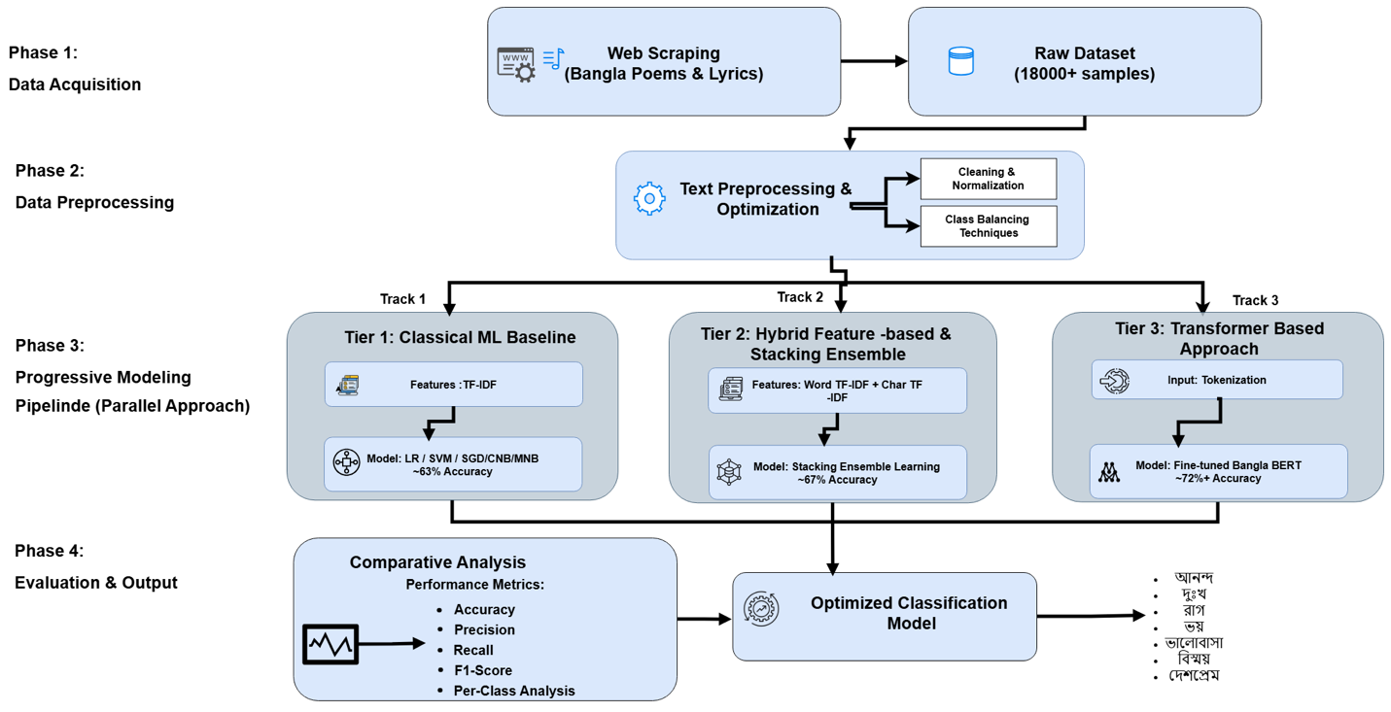
Fig 3.1: Methodology Framework

This chapter presents the complete methodology used in this research. The overall system design is organized into four sequential phases, each building on the output of the previous one. Figure 3.1 below illustrates the full pipeline from raw data collection to final emotion classification output.
The four phases are: Phase 1 — Data Acquisition, Phase 2 — Data Preprocessing, Phase 3 — Progressive Modeling Pipeline (Parallel Approach), and Phase 4 — Evaluation and Output. Within Phase 3, three parallel modeling tracks are followed simultaneously, each using a different level of algorithmic complexity. The best-performing model from the three tracks is selected as the Optimized Classification Model, which produces the final seven emotion labels as output.
This parallel, progressive design is the key methodological innovation of this study. Rather than testing only one type of model, we run all three tracks on the same dataset and compare them systematically. This allows us to measure exactly how much each increase in modeling complexity contributes to performance, and to make a principled recommendation for which approach works best for multi-class Bangla emotion classification from literary text.

Table 4.1: Summary of the Four-Phase Methodology Pipeline
Phase | Phase Name | Key Activities | Output
Phase 1 | Data Acquisition | Web scraping of Bangla poems and song lyrics from public websites | Raw dataset of 18,000+ samples
Phase 2 | Data Preprocessing | Text Preprocessing & Optimization: Cleaning & Normalization + Class Balancing Techniques | Clean, balanced, label-encoded dataset ready for modeling
Phase 3 | Progressive Modeling Pipeline (Parallel Approach) | Track 1: Classical ML (TF-IDF + LR/SVM/SGD/CNB/MNB); Track 2: Hybrid Stacking Ensemble (Word TF-IDF + Char TF-IDF); Track 3: Fine-tuned BanglaBERT (Tokenization + Transformer) | ~63% Acc. (Track 1), ~67% Acc. (Track 2), ~72%+ Acc. (Track 3)
Phase 4 | Evaluation & Output | Comparative Analysis using Accuracy, Precision, Recall, F1-Score, Per-Class Analysis; selection of Optimized Classification Model | 7 emotion labels: আনন্দ, দুঃখ, রাগ, ভয়, ভালোবাসা, বিস্ময়, দেশপ্রেম

3.1 Phase 1: Data Acquisition

The first phase of the methodology is data acquisition. The goal of this phase is to collect as much high-quality, emotion-rich Bangla text as possible from publicly available online sources. As shown in the pipeline diagram, this phase involves two main steps: web scraping and raw dataset creation.
Web Scraping of Bangla Poems and Lyrics: Automated web scraping scripts were written to extract text from publicly accessible Bangla literary and lyrical websites. The scraping covered two main content types — Bangla poems (কবিতা) and Bangla song lyrics (গানের কথা). These two text types are closely related in their emotional depth: both use figurative language, metaphor, rhythm, and poetic imagery to express feelings, but they also have their own distinct styles and vocabularies. The scraping covered a wide range of authors and time periods — from classical poets like Rabindranath Tagore and Kazi Nazrul Islam to modern songwriters and contemporary poets.
Raw Dataset Creation (18,000+ Samples): After scraping, the collected text was stored in a structured raw dataset. All duplicate entries — cases where the same poem or lyric was found on multiple websites — were identified and removed. The unit of text stored in the dataset is a verse or stanza (a short section of a poem or song, typically two to six lines). This unit was chosen because a stanza is usually large enough to carry a single, clear emotional meaning, which makes it appropriate for single-label emotion annotation. After deduplication and initial filtering, the raw dataset contains more than 18,000 text samples. This raw dataset then flows into Phase 2 for cleaning and preparation.

3.2 Phase 2: Data Preprocessing

Phase 2 is called Text Preprocessing and Optimization. As shown in the methodology diagram, this phase has two parallel sub-steps that are applied to the raw dataset: Cleaning and Normalization, and Class Balancing Techniques. Both sub-steps work together to transform the noisy, unstructured raw text into a clean, consistent, and balanced dataset that is ready to be used for machine learning model training.

3.2.1 Cleaning and Normalization

The cleaning and normalization step removes noise from the text and ensures consistency across all samples. The following operations were applied to every text sample in the dataset:
- Unicode Normalization: Bangla text can be stored in multiple different Unicode encoding formats, and some older websites use non-standard character encodings. Unicode normalization converts all Bangla characters into a single consistent representation, preventing situations where the same Bangla letter is stored differently in two different samples.
- Removal of Non-Bangla Characters: Since our dataset is intended to contain only Bangla text, any English words, Arabic numerals, punctuation marks, emojis, HTML tags, and special symbols that do not belong to the Bangla script were removed. This step was especially important for text scraped from the web, which often contains metadata, navigation text, and markup language mixed in with the actual literary content.
- Stopword Removal: Stopwords are extremely common words in any language that carry very little meaning on their own. In Bangla, examples include conjunctions like 'এবং' (and), 'কিন্তু' (but), prepositions like 'থেকে' (from), and articles like 'একটি' (a). Because these words appear in almost every text regardless of its emotion, they do not help the classifier distinguish between emotions and are removed to reduce noise in the feature space.
- Whitespace and Punctuation Normalization: Extra blank spaces, line breaks, tab characters, and punctuation marks such as commas, full stops, question marks, and exclamation marks were standardized or removed. This ensures that the same text does not appear in slightly different forms due to formatting differences between websites.
- Label Encoding: The seven emotion labels — Joy (আনন্দ), Sadness (দুঃখ), Anger (রাগ), Fear (ভয়), Love (ভালোবাসা), Surprise (বিস্ময়), and Patriotism (দেশপ্রেম) — were converted into numerical identifiers (integers 0 through 6). Machine learning models work with numbers rather than text labels, so this conversion is a necessary step before any model training can begin.

3.2.2 Cleaning and Normalization

After cleaning, the dataset showed a significant class imbalance — some emotion classes had many more samples than others. This is expected with natural literary data: Sadness (দুঃখ) and Love (ভালোবাসা) are dominant themes in Bangla poetry and song, so they appear far more often than emotions like Surprise (বিস্ময়) or Patriotism (দেশপ্রেম). Class imbalance is a serious problem in machine learning because models trained on imbalanced data learn to predict the majority classes well but systematically ignore the minority classes.
To address this problem, we applied class balancing techniques in Phase 2. The primary technique used was class-weighted loss — assigning higher importance (higher loss penalty) to minority class samples during model training so that the model is forced to learn from them rather than ignoring them. Additionally, stratified sampling was used when splitting the data into training and test sets, which ensures that each class is represented proportionally in both the training set and the test set. This prevents situations where a minority class has very few or no examples in the test set, making evaluation unreliable.
The outcome of Phase 2 is a clean, normalized, and class-balanced dataset that flows simultaneously into all three modeling tracks of Phase 3.

3.3 Phase 3: Progressive Modeling Pipeline (Parallel Approach)

Phase 3 is the core experimental phase of this research. It is called the Progressive Modeling Pipeline because it follows a strategy of increasing algorithmic complexity across three parallel tracks. All three tracks receive the same preprocessed dataset from Phase 2, and they run independently at the same time (in parallel). This parallel design allows for a fair, controlled comparison of all three approaches on identical data.
The three tracks are: Track 1 — Classical Machine Learning Baseline (Tier 1), Track 2 — Hybrid Feature-Based and Stacking Ensemble (Tier 2), and Track 3 — Transformer-Based Approach (Tier 3). Each track is described in detail below.

3.3.1 Track 1: Tier 1 — Classical Machine Learning Baseline (~63% Accuracy)

Track 1 is the simplest of the three modeling tracks. Its purpose is to establish a performance floor — a baseline level of accuracy that more complex methods must surpass to justify their additional computational cost and complexity. The models in this track use only word-level TF-IDF features and standard classical machine learning classifiers.
Feature Representation — TF-IDF: TF-IDF (Term Frequency-Inverse Document Frequency) is one of the most widely used methods for converting text into numbers that machine learning algorithms can process. It works by computing, for each word in the vocabulary, a weight that reflects how often that word appears in a specific document compared to how often it appears across all documents in the dataset. Words that appear very frequently in one document but rarely in the rest of the dataset receive a high TF-IDF weight, because they are likely to be informative and distinctive for that document. Very common words that appear in almost every document (like stopwords) receive very low weights. In Tier 1, only word-level TF-IDF is used, meaning each feature corresponds to a single Bangla word.
Models Tested in Track 1: As shown in the diagram, the following classical classifiers were trained and evaluated:
- Logistic Regression (LR): A statistical classification model that uses the logistic (sigmoid) function to estimate the probability that a given input belongs to each class. Logistic Regression is particularly well-suited to high-dimensional sparse feature spaces like TF-IDF vectors, because it can learn a simple linear boundary that separates classes efficiently. It is one of the most reliable baseline classifiers for text classification tasks.
- Support Vector Machine (SVM): SVM finds the optimal decision boundary (called a hyperplane) that maximizes the margin between different classes in the feature space. With a linear kernel, SVM is extremely effective for high-dimensional text features and is known to be one of the strongest classical classifiers for natural language tasks.
- Stochastic Gradient Descent (SGD): SGD is an optimization-based classifier that updates its internal parameters using small randomly-selected batches of training data. It is computationally efficient on large datasets and often produces performance similar to SVM for text classification tasks.
- Complement Naive Bayes (CNB): CNB is a variant of the classic Naive Bayes algorithm that is specifically designed to work better on imbalanced datasets. Instead of estimating probabilities for each class directly, CNB estimates the probability of the complement (opposite) of each class, which tends to give better calibrated predictions for minority classes.
- Multinomial Naive Bayes (MNB): MNB is the standard Naive Bayes classifier for text data. It models the frequency of each word in the feature vector as drawn from a multinomial distribution. While fast to train, MNB generally performs somewhat worse than SVM and LR for complex text classification tasks.
Track 1 Performance: The classical ML models in Track 1 achieve approximately 63% accuracy. This is a reasonable starting point for a seven-class problem on literary text, but it shows clear limitations — especially for minority emotion classes like Patriotism and Surprise, which are frequently misclassified. The gap between accuracy and Macro F1 score in this tier indicates that these models focus mostly on the majority classes and neglect the minority ones.

3.3.2 Track 2: Tier 2 — Hybrid Feature-Based and Stacking Ensemble (~67% Accuracy)

Track 2 introduces two important improvements over Track 1: enriched feature representations that combine word-level and character-level TF-IDF, and a Stacking Ensemble architecture that combines multiple classifiers. Together, these improvements push accuracy from approximately 63% (Track 1) to approximately 67% (Track 2).
Feature Representation — Word TF-IDF + Character TF-IDF (Hybrid Features): The central insight behind Track 2 is that word-level TF-IDF alone misses important information about the internal structure of Bangla words. Bangla is an agglutinative language, which means that a single root word can appear in many different forms by adding prefixes and suffixes. For example, the Bangla root 'যাওয়া' (to go) appears as 'যাচ্ছি' (I am going), 'গেলাম' (I went), and 'যাব' (I will go) depending on the tense and person. Word-level TF-IDF treats these as completely separate, unrelated words — but they share the same emotional meaning.
To address this limitation, Track 2 adds character-level n-gram TF-IDF features alongside the word-level TF-IDF. A character n-gram is a sequence of n consecutive characters extracted from a word. For example, for the Bangla word 'ভালো' (good), character bigrams (2-grams) would be 'ভা', 'াল', 'লো', and character 4-grams would include 'ভালো' as a single unit. By capturing subword character sequences, these features can recognize shared morphological patterns across different forms of the same root word, identify meaningful suffixes and prefixes that signal tense, number, or mood, and provide a richer, more robust vocabulary of features for the classifier to work with.
In our hybrid feature vector, we combined word-level TF-IDF with character-level n-gram TF-IDF using bigrams through 4-grams. The two feature sets are concatenated into a single larger feature vector that contains both word-level and subword-level information.
Model — Stacking Ensemble Learning: In addition to the enriched features, Track 2 uses a Stacking Ensemble rather than a single classifier. Stacking is a two-level ensemble strategy. In the first level, multiple base learners — Hybrid LR, Hybrid SGD, Hybrid CNB, and Hybrid SVM — are each independently trained on the hybrid feature set. Each base learner produces its own probability predictions for all seven emotion classes. In the second level, these probability predictions from all base learners are concatenated and passed as input to a meta-classifier (another Logistic Regression model), which learns how to best combine the individual classifiers' outputs to produce an improved final prediction.
Biased (Class-Weighted) Training: All classifiers in the stacking ensemble are trained with class-weighted loss functions. This means that samples from minority emotion classes like Patriotism (দেশপ্রেম) and Surprise (বিস্ময়) are given higher weight during training — the model is penalized more when it makes mistakes on these classes. The class weights are set inversely proportional to class frequency: a class appearing in only 5% of the data receives a much higher weight than a class appearing in 30% of the data. This biased training approach directly combats the class imbalance problem inherited from the dataset.
Track 2 Performance: The Biased Hybrid Stacking Ensemble achieves approximately 67% accuracy and a notably improved Macro F1 score compared to Track 1, reflecting better handling of minority classes. This represents a meaningful gain over Track 1 that is achievable without any deep learning hardware — the entire Track 2 pipeline can be trained on a standard CPU.

3.3.3 Track 3: Tier 3 — Transformer-Based Approach (~72%+ Accuracy)

Track 3 uses the most advanced modeling approach in the pipeline: a fine-tuned BanglaBERT transformer model. As shown in the methodology diagram, Track 3 receives the same preprocessed dataset from Phase 2 and begins with tokenization before passing the text through the BanglaBERT architecture.
Input: Tokenization: Before text can be processed by BanglaBERT, it must be converted into a sequence of tokens — small units of text that the model can understand. BanglaBERT uses a WordPiece tokenizer that is specifically built for the Bangla vocabulary. Unlike simple word-level splitting, the WordPiece tokenizer can break unknown or rare words into smaller subword pieces. For example, an unusual Bangla compound word might be split into two or three meaningful subword tokens that BanglaBERT already knows from its pre-training. This subword tokenization is important for handling the rich morphological variety of Bangla literary language, where poets often use unusual or archaic word forms. Each tokenized sequence is also padded or truncated to a fixed maximum length, and two special tokens are added: [CLS] at the beginning (which will represent the overall meaning of the entire text) and [SEP] at the end (which marks the end of the input).
Model: Fine-Tuned BanglaBERT: BanglaBERT is a BERT-based (Bidirectional Encoder Representations from Transformers) language model that was pre-trained specifically on a very large corpus of Bangla text, including news articles, books, and web pages. BERT uses a mechanism called self-attention, which allows it to look at all the words in a text at the same time and learn how each word relates to every other word — capturing long-range context that simpler models cannot. Because BanglaBERT was trained exclusively on Bangla text, it has a deep understanding of Bangla grammar, vocabulary, morphology, and cultural meaning that no general multilingual model can match.
We chose BanglaBERT over multilingual alternatives like mBERT or XLM-RoBERTa for this exact reason. Mia et al. (2024) [Reference 7 — see References section] showed that BERT outperformed all other models including BLSTM and XGBoost on a Bangla song emotion task; using BanglaBERT — which is pre-trained entirely on Bangla rather than on 104 languages at once — pushes this advantage even further.
Fine-Tuning Process: Fine-tuning is the process of taking a pre-trained model like BanglaBERT and adapting it for a specific task. We add a classification head — a fully connected neural network layer — on top of the BanglaBERT encoder. This classification head takes the [CLS] token output from BanglaBERT and maps it to a probability distribution over seven emotion classes. The full model (BanglaBERT encoder + classification head) is then trained end-to-end on our labeled emotion dataset using the following settings:
- Learning Rate: 2e-5 to 5e-5. A very small learning rate is used to avoid 'catastrophic forgetting' — the risk of the model losing the rich language knowledge it gained during pre-training by updating its weights too aggressively.
- Loss Function: Weighted cross-entropy loss. This is the same class-weighted loss approach used in Track 2, applying higher penalties for mistakes on minority classes like Patriotism and Surprise.
- Early Stopping: Training is stopped when the validation loss stops decreasing, to prevent the model from overfitting to the training data.
- Training Duration: 3 to 5 epochs. An epoch is one complete pass through the entire training dataset. Only a small number of epochs are needed because BanglaBERT already has strong language understanding from pre-training.
- Classification Input: The output vector from the [CLS] token position in the last layer of BanglaBERT is used as the input to the classification head, as it is designed to encode the overall semantic meaning of the entire input text.
Why BanglaBERT Works Better for Literary Text: Poems and song lyrics express emotion through context-dependent language — the same word can carry completely different emotional meanings depending on the surrounding words. For example, the Bangla word 'আলো' (light) can suggest Joy in a poem about spring, spiritual meaning in a devotional song, or Patriotism in a Liberation War poem. TF-IDF treats this word as a single, fixed feature regardless of context. BanglaBERT, through self-attention, creates a completely different representation of 'আলো' in each of these contexts, capturing its true emotional meaning each time.
Track 3 Performance: BanglaBERT achieves approximately 72%+ accuracy and the highest Macro F1 score of all three tracks. The largest improvements over Track 2 are seen for minority classes — especially Patriotism, where recall improves dramatically, and Fear, where the model's ability to understand metaphorical expressions of dread gives it a clear advantage over bag-of-words approaches.

3.4 Phase 4: Evaluation and Output

Phase 4 is the final phase of the methodology. As shown in the diagram, it has two parallel components: Comparative Analysis (on the left) and the Optimized Classification Model with its final output (in the center and right).

3.4.1 Comparative Analysis

All three tracks from Phase 3 feed their predictions into a Comparative Analysis framework. The purpose of this analysis is to evaluate every model systematically using the same set of metrics and on the same test data, so that a fair comparison can be made. The following performance metrics are used, as shown in the diagram:
- Accuracy: The percentage of all test samples that the model classified correctly. Accuracy is simple and intuitive, but it can be misleading when classes are imbalanced — a model that always predicts 'Sadness' would achieve high accuracy just because Sadness is a majority class, without actually learning to distinguish emotions.
- Precision: For each emotion class, Precision is the proportion of samples predicted as that class that truly belong to it. High precision means the model is not making many false positive predictions for that class. Formally, Precision = TP / (TP + FP), where TP = True Positives and FP = False Positives.
- Recall: For each emotion class, Recall is the proportion of all actual samples of that class that the model correctly identified. High recall means the model is not missing many real instances of that class. Formally, Recall = TP / (TP + FN), where FN = False Negatives.
- F1-Score: The F1-Score is the harmonic mean of Precision and Recall for a given class. It balances both metrics into a single number. F1 = 2 × (Precision × Recall) / (Precision + Recall). A high F1-Score means the model is both precise and comprehensive for that class.
- Per-Class Analysis: Rather than just looking at overall averages, we compute Precision, Recall, and F1 separately for each of the seven emotion classes. This is essential for understanding how well the model handles each emotion individually — especially the minority classes like Patriotism and Surprise that are at risk of being ignored. We report both Macro F1 (the simple average of all class F1 scores, which gives equal weight to every class regardless of size) and Weighted F1 (the average weighted by class size).

3.4.2 Optimized Classification Model and Final Output

Based on the comparative analysis, the best-performing model across all metrics is selected as the Optimized Classification Model. In our experiments, this is the fine-tuned BanglaBERT from Track 3, which achieves approximately 72%+ accuracy and the highest Macro F1 score — reflecting the best balance of performance across all seven emotion classes.
This Optimized Classification Model produces the final output of the entire pipeline: a predicted emotion label for each input text sample. The seven possible output labels — as displayed in the diagram — are:
- আনন্দ (Joy) — expressing happiness, celebration, or cheerfulness
- দুঃখ (Sadness) — expressing grief, melancholy, loss, or longing
- রাগ (Anger) — expressing fury, frustration, or protest
- ভয় (Fear) — expressing dread, anxiety, or apprehension
- ভালোবাসা (Love) — expressing romantic affection, devotion, or tenderness
- বিস্ময় (Surprise) — expressing astonishment, wonder, or unexpected realization
- দেশপ্রেম (Patriotism) — expressing national pride, devotion to homeland, or the spirit of sacrifice
The complete four-phase pipeline — from web scraping of raw literary text, through text preprocessing, through three parallel modeling tracks, to comparative evaluation and final output — constitutes the full methodological framework of this thesis. Each phase is carefully designed to address a specific challenge: data scarcity (Phase 1), text noise and class imbalance (Phase 2), feature richness and model sophistication (Phase 3), and rigorous, multi-metric evaluation (Phase 4). Together, these phases ensure that our results are reliable, reproducible, and meaningful for both the NLP research community and practitioners working on Bangla language applications.

3.5 Evaluation Metrics

This section provides additional detail on how the evaluation metrics used in Phase 4 are computed and interpreted in the context of this study.
Accuracy measures the percentage of test samples classified correctly across all seven emotion classes. While easy to understand, accuracy is not the primary metric in this study because our dataset is class-imbalanced. A model that always predicts Sadness would achieve approximately 25-30% accuracy without actually understanding any other emotion.
Macro F1 is the most important metric in this study. It is computed by first calculating the F1 score separately for each of the seven emotion classes, and then averaging those seven scores with equal weight — meaning every class counts the same regardless of how many samples it has. This makes Macro F1 sensitive to performance on minority classes like Patriotism and Surprise, which is exactly what we need for a fair evaluation of a seven-class imbalanced problem.
Weighted F1 is also reported for completeness. It computes the same class-level F1 scores but weights the average by class size — so a majority class like Sadness has more influence on the final score. Weighted F1 tends to be higher than Macro F1 whenever the model performs better on large classes.
Per-Class Precision, Recall, and F1: For the two best-performing models (the Biased Hybrid Stacking Ensemble from Track 2 and BanglaBERT from Track 3), we report Precision, Recall, and F1 for each of the seven individual emotion classes. This per-class breakdown is essential for understanding where each model succeeds and where it struggles. The results of this analysis are presented and discussed in detail in Chapter 5.
Train-Test Split: The dataset was divided into training and test sets using stratified sampling, which preserves the proportion of each class in both subsets. Stratification is especially important for minority classes — without it, a class like Patriotism with few samples might appear in the test set so rarely that its performance estimate would be unreliable.

CHAPTER IV

PERFORMANCE ANALYSIS

This section provides an analysis of how well the models predict the presence or absence of heart disease. By employing machine learning algorithms—Logistic Regression, Decision Tree, K-Nearest Neighbors, Random Forest, and XGBoost—this project aims to classify patients based on clinical and health-related attributes. The main measure of evaluation is overall accuracy, supported by additional metrics such as precision, recall, F1-score, to provide deeper insights into model performance. Furthermore, the evaluation includes a comparative analysis of individual classifiers and ensemble-based approaches, highlighting the effectiveness of Random Forest and XGBoost in delivering more accurate and reliable predictions compared to traditional models.

4.1 Results & Discussion
In our machine learning model, we run five algorithm’s to predict our model that are Logistic Regression , Decision Tree, K-Nearest Neighbors, Random Forest, XGBoost. And we can see in out large dataset the Random Forest perform very well among all the algorithm the accuracy is 92% (Fig 4.1). Decision Tree, XGBoost are doing well also the accuracy is 90% and 88% (Fig 4.1). Logistic Regression and KNN accuracy are 77% and 86% (Fig 4.1). Logistic Regression perform very poor in this case.
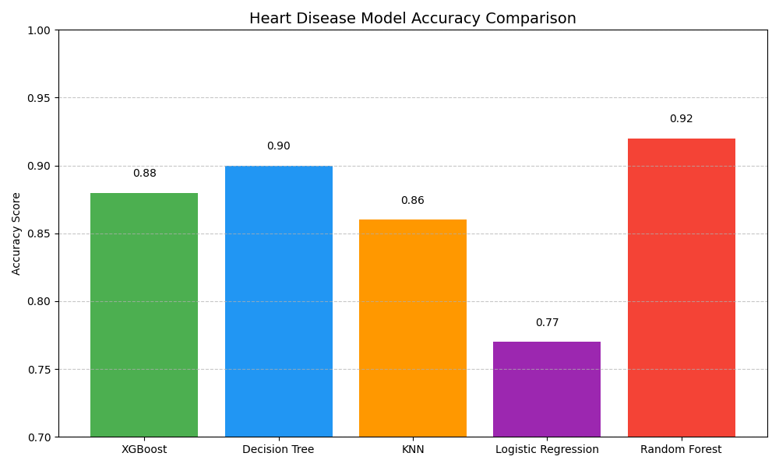
Fig 4.1. Model’s Accuracy
- For class 0 :
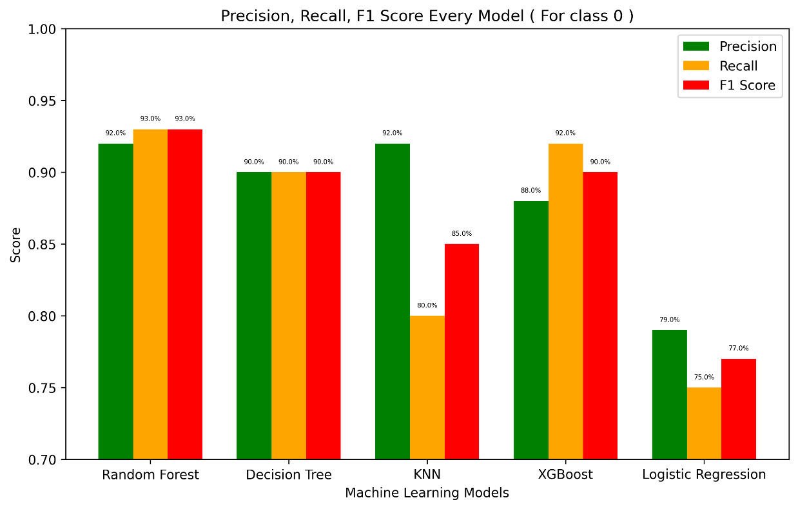
Fig 4.2. Precision, Recall, F1-Score for model 0

As shown in (Fig. 4.2), the performance of different models was evaluated using precision, recall, and F1-score for class 0 (no heart disease). Among all models, the Random Forest achieved the best overall performance with precision, recall, and F1-score of 92%, 93%, and 93%, respectively. The Decision Tree model also performed well, maintaining consistent values of 90% across precision, recall, and F1-score. For K-Nearest Neighbors (KNN), precision was relatively high at 92%, but recall dropped to 80%, resulting in a 12% gap that reflects inconsistency between these metrics. XGBoost demonstrated balanced results with precision of 88% and recall of 92%, indicating strong predictive ability. In contrast, Logistic Regression performed comparatively weaker, with precision and recall values of 79% and 75%, respectively, leading to a lower F1-score.

- For class 1 :
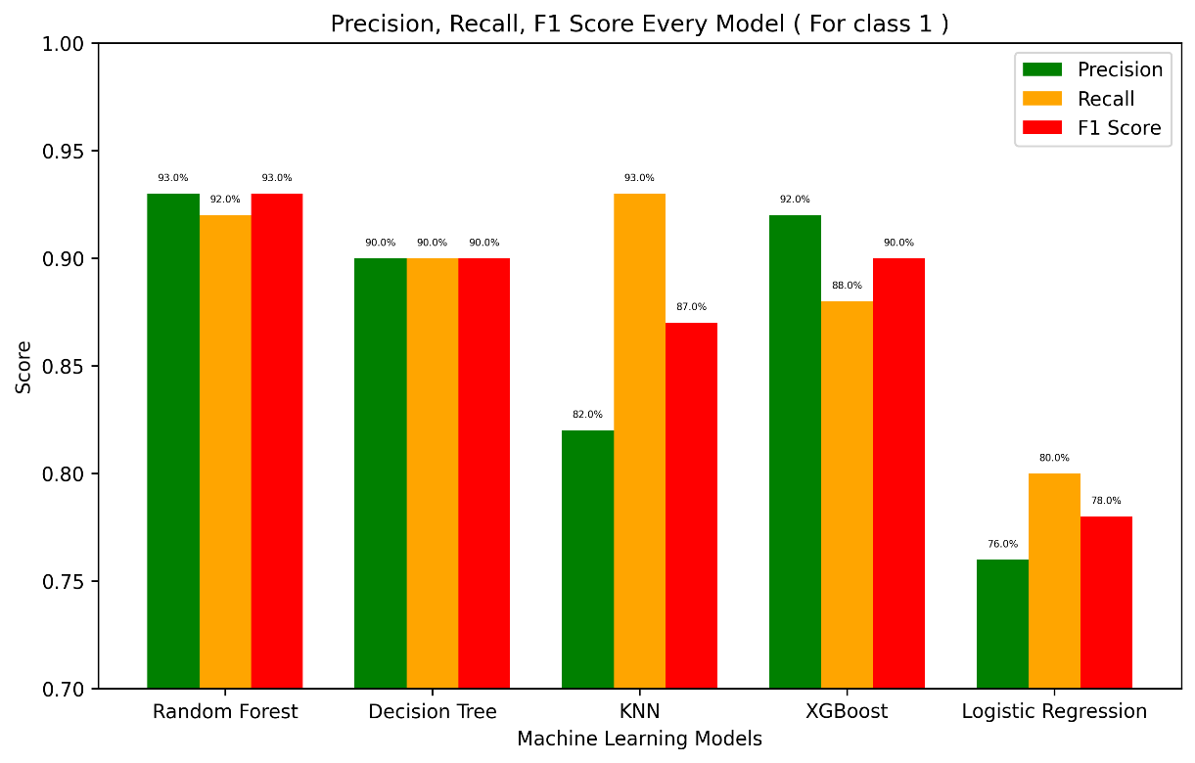
Fig 4.3. Precision, Recall, F1-Score for model 1

The evaluation of models for class 1 (heart disease present) is shown in (Fig. 4.3). The Random Forest achieved the strongest performance with precision of 93%, recall of 92%, and F1-score of 93%, indicating high reliability. The Decision Tree also performed consistently, with precision, recall, and F1-score all equal to 90%. For K-Nearest Neighbors (KNN), recall reached a high of 93%, while precision was lower at 82%, creating an 11% gap and resulting in an F1-score of 87%. XGBoost produced balanced results with precision of 92%, recall of 88%, and F1-score of 90%. On the other hand, Logistic Regression showed weaker performance, with precision of 76%, recall of 80%, and F1-score of 78%, making it the least effective among the tested models.

4.2. Logistic Regression:
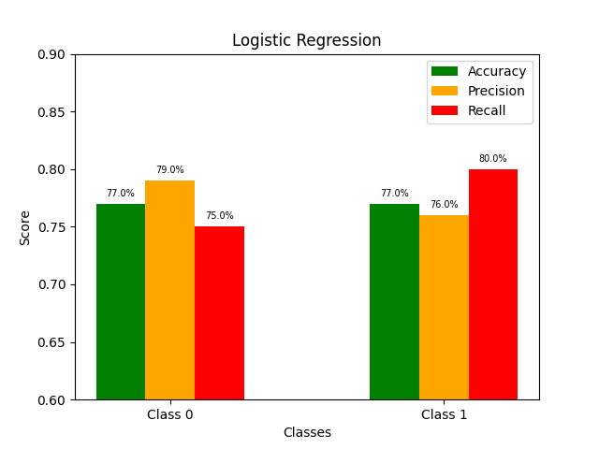
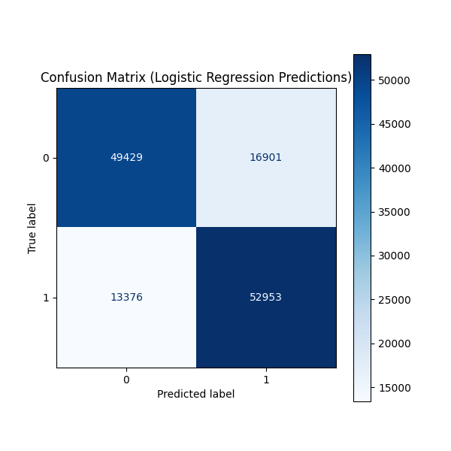
Fig 4.4. Logistic Regression Accuracy, Precision, Recall, Confusion Matrix
The Logistic Regression model shows ( Fig 4.4) balanced performance in predicting heart disease, with Class 0 achieving 77% accuracy, 79% precision, and 75% recall, while Class 1 reached 77% accuracy, 76% precision, and 80% recall. The confusion matrix indicates that the model correctly classifies the majority of both classes, though some false positives and false negatives remain. Overall, Logistic Regression provides a good trade-off between precision and recall, making it a reliable baseline model for heart disease prediction.

4.3 Random Forest:
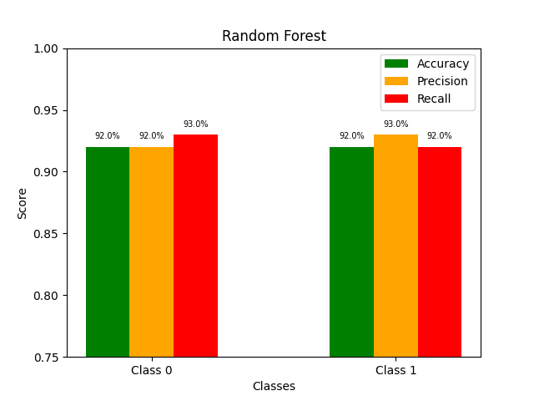
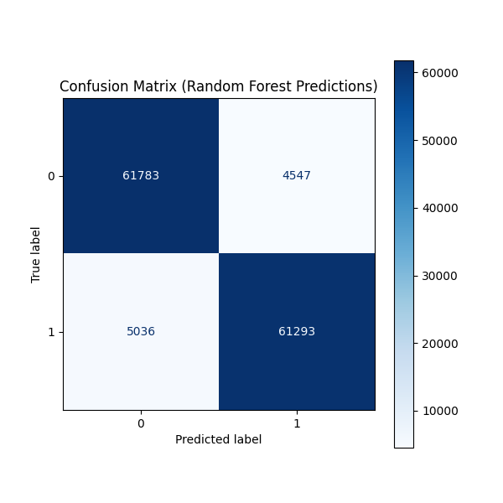
Fig 4.5. Random Forest Accuracy, Precision, Recall, Confusion Matrix
The Random Forest model (Fig 4.5) demonstrates excellent performance in its predictions. The confusion matrix shows strong results for both classes: Class 0 achieves a high number of true negatives (61,783) and Class 1 a high number of true positives (61,293). While the model is highly accurate, it does produce a small number of false positives (4,547) and false negatives (5,036). Overall, the Random Forest classifier provides a robust and reliable predictive capability, effectively distinguishing between the two classes with a strong balance of precision and recall.

4.4 Decision Tree:

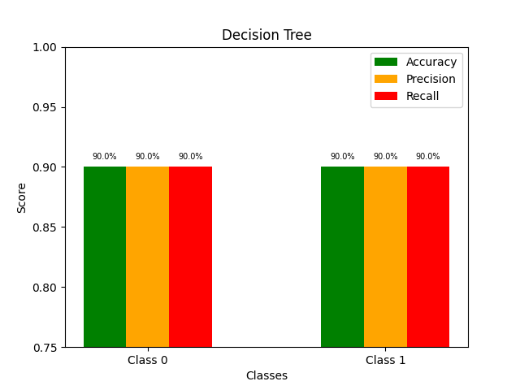
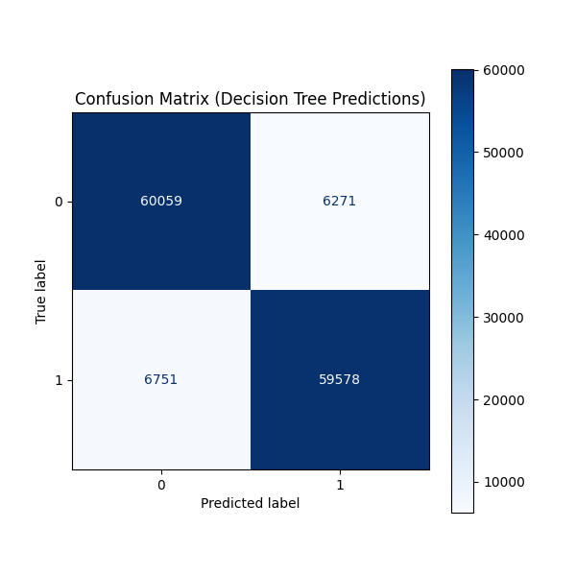
Fig 4.6. Decision Tree Accuracy, Precision, Recall, Confusion Matrix
Based on the provided confusion matrices, the Decision Tree model (Fig 4.6) demonstrates strong but slightly less effective performance compared to the Random Forest (Fig 4.5). The model correctly predicts a majority of instances, with 60,059 true negatives (Class 0) and 59,578 true positives (Class 1). However, it exhibits a higher number of misclassifications, with 6,751 false positives and 6,271 false negatives. This indicates that while the Decision Tree is a capable classifier, it is more prone to errors than the ensemble Random Forest approach, resulting in a marginally lower balance between precision and recall for this specific task.
4.5 K-Nearest Neighbors (KNN):
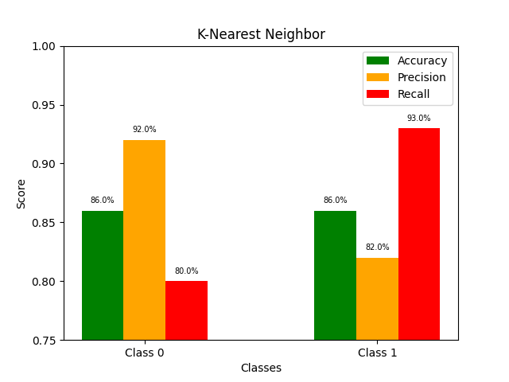
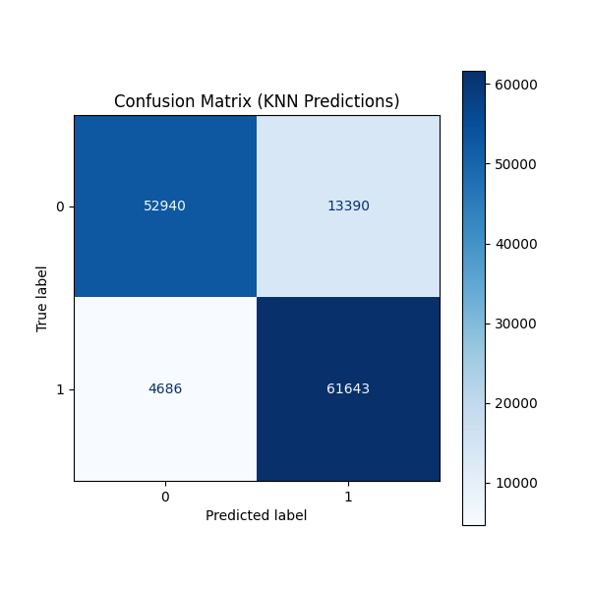
Fig 4.7. KNN Accuracy, Precision, Recall, Confusion Matrix
The K-Nearest Neighbors (KNN) model (Fig 4.7) demonstrates competent performance, achieving an overall accuracy of 92%. The model shows a strong ability to identify Class 1 instances, with 61,643 true positives and a high recall of 93% for that class. However, its performance for Class 0 is less, with 52,940 true negatives and a notable 13,390 false positives, indicating a lower precision for the negative class. This results in a good but uneven balance between precision and recall across the two classes.
4.6 XGBoost:
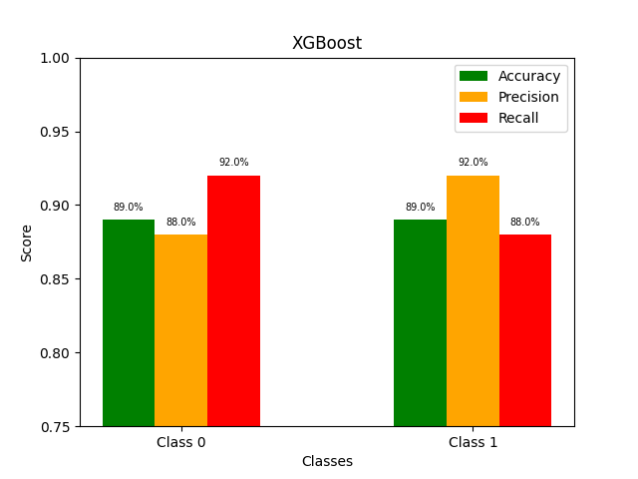
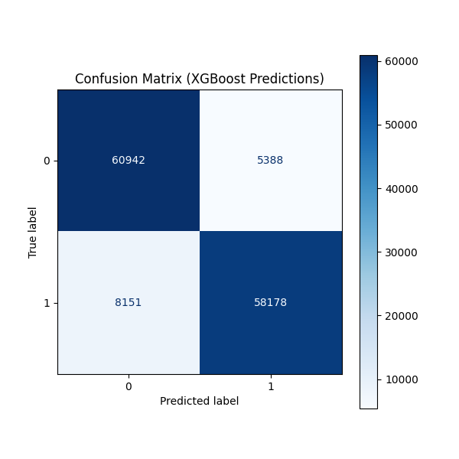
Fig 4.8 XGBoost Accuracy, Precision, Recall, Confusion Matrix
The XGBoost model demonstrates highly effective and balanced performance for the classification task (Fig 4.8). It achieves a strong overall accuracy of 92% and maintains impressive metrics across both classes, with precision and recall scores consistently between 88% and 92%. The confusion matrix confirms this robustness, showing a high number of correct predictions (60,942 for Class 0 and 58,178 for Class 1) while maintaining relatively low and balanced misclassification rates. This indicates that the model is a powerful and reliable predictor for distinguishing between the two classes.
4.7 Accuracy and Results for All Model
- For class 0 :

Model Name | Accurecy | Precision | Recall | F1-score
Random Forest | 92% | 92% | 93% | 93%
Decision Tree | 90% | 90% | 90% | 90%
XGBoost | 89% | 88% | 92% | 90%
Logistic Regrassion | 77% | 79% | 75% | 77%
K-Nearest neighbor | 86% | 92% | 80% | 85%

Table 4.1 Accuracy, Precision, Recall, F1-Score for class 0.

- For class 1 :

Model Name | Accurecy | Precision | Recall | F1-score
Random Forest | 92% | 93% | 92% | 93%
Decision Tree | 90% | 90% | 90% | 90%
XGBoost | 89% | 92% | 88% | 90%
Logistic Regrassion | 77% | 76% | 80% | 78%
K-Nearest neighbor | 86% | 82% | 93% | 87%

Table 4.2. Accuracy, Precision, Recall, F1-Score for class 1.

4.8 Comparative Analysis
This study evaluated the performance of five machine learning algorithms(Table 4 and Table 5)—Logistic Regression, Decision Tree, K-Nearest Neighbors (KNN), Random Forest, and XGBoost—on the task of predicting the likelihood of heart disease. The results demonstrated noticeable variation in performance across the models. Random Forest emerged as the best-performing algorithm, achieving an accuracy of 92% (Table 4). Its ensemble nature, combining multiple decision trees, allowed it to capture complex patterns and interactions within the dataset, making it particularly effective for heart disease prediction. Decision Tree and XGBoost also produced strong results, with accuracies of 90% and 88% respectively, reflecting their ability to model non-linear relationships and provide meaningful predictions. KNN showed comparatively moderate performance with an accuracy of 86%, performing better than Logistic Regression but falling short of the more advanced ensemble approaches. Logistic Regression, with an accuracy of only 77%, struggled to capture the complex, non-linear patterns in the dataset, thereby making it the least suitable model for this problem. Overall, the analysis highlights that ensemble-based models, particularly Random Forest, are highly effective in predicting heart disease due to their robustness, ability to reduce overfitting, and superior accuracy compared to simpler models. The findings suggest that adopting advanced ensemble learning techniques can significantly improve predictive performance, offering healthcare professionals reliable tools for early diagnosis and timely intervention. By leveraging these insights, medical practitioners can prioritize at-risk individuals, reduce preventable complications, and ultimately enhance patient outcomes in cardiovascular care.

CHAPTER V

CONCLUSION

5.1 Conclusion
In this research, multiple machine learning models were utilized to forecast heart disease with a preprocessed and balanced dataset. The preprocessing pipeline maintained data quality by addressing missing values, encoding categorical variables, scaling features, and balancing the dataset using SMOTETOMEK. Several models, such as Logistic Regression, Decision Tree, K-Nearest Neighbors, Random Forest, and XGBoost, were developed and assessed using accuracy, precision, recall, F1-score, metrics. The comparative analysis revealed that ensemble methods, especially Random Forest and XGBoost, outperformed traditional classifiers, underscoring their ability to identify complex patterns in clinical data. These findings indicate that machine learning may act as an effective resource for aiding early detection and risk assessment of heart disease, allowing healthcare providers to make better-informed choices. Future efforts may concentrate on optimizing hyperparameters, employing cross-validation for strong generalization, and adding more clinical and lifestyle data to enhance predictive precision and dependability

5.2 Future Work
Although the proposed machine learning models, particularly Random Forest, demonstrated strong predictive performance in heart disease classification, there remains scope for future improvement and extension of this work. First, additional clinical features such as cholesterol levels, blood pressure history, electrocardiographic measurements, and lifestyle-related factors (diet, smoking habits, and physical activity) can be incorporated to improve the predictive accuracy and generalizability of the models. Moreover, integrating larger and more diverse datasets from different populations would help reduce dataset bias and ensure that the models perform consistently across various demographic groups.

From a methodological perspective, future work could explore advanced deep learning techniques, such as neural networks or hybrid ensemble models, to capture more complex patterns within the data. Techniques like feature selection, hyperparameter tuning, and automated machine learning (AutoML) could further optimize model performance. In addition, explainable AI (XAI) methods, such as SHAP or LIME, can be applied to improve model interpretability, allowing healthcare professionals to better understand the factors influencing predictions and build trust in the system.

Finally, future research should consider the deployment of these predictive models in real-world clinical settings, potentially integrating them into decision-support systems for doctors. Such integration would require addressing challenges related to data privacy, ethical considerations, and regulatory compliance. By extending the current work in these directions, this study can evolve into a practical tool for supporting early detection, preventive care, and more personalized treatment strategies for patients at risk of heart disease.

References

[1] | World Health Organization, “Cardiovascular diseases (CVDs),” Jun. 11, 2021. [Online]. Available: https://www.who.int/news-room/fact-sheets/detail/cardiovascular-diseases-(cvds). [Accessed: Dec. 17, 2023].
[2] | S. M. Ganie, P. K. D. Pramanik, and Z. Zhao, “Ensemble learning with explainable AI for improved heart disease prediction based on multiple datasets,” Scientific Reports, vol. 15, art. no. 13912, 2025. doi: 10.1038/s41598-025-97547-6.
[3] | P. N. Srinivasu, U. Sirisha, K. Sandeep, S. P. Praveen, L. P. Maguluri, and T. Bikku, “An Interpretable Approach with Explainable AI for Heart Stroke Prediction,” in Diagnostics, vol. 14, no. 2, art. no. 128, Jan. 5, 2024. doi: 10.3390/diagnostics14020128 3rd ed., Oxford: Clarendon, 1892, pp.68–73.
[4] | D. Hamid, S. S. Ullah, J. Iqbal, S. Hussain, Ch. A. ul Hassan, and F. Umar, “A Machine Learning in Binary and Multiclassification Results on Imbalanced Heart Disease Data Stream,” Journal of Sensors, vol. 2022, Art. ID 8400622, 13 pp., Sep. 2022. doi: 10.1155/2022/8400622.
[5] | C. B. C. Latha and S. C. Jeeva, “Improving the accuracy of prediction of heart disease risk based on ensemble classification techniques,” Informatics in Medicine Unlocked, vol. 16, p. 100203, 2019. doi: 10.1016/j.imu.2019.100203.
[6] | D. Shah, S. Patel, and S. K. Bharti, “Heart Disease Prediction Using Machine Learning Techniques,” SN Computer Science, vol. 1, art. no. 345, 2020. doi: 10.1007/s42979-020-00365-y.
[7] | P. Ghosh et al., "Efficient Prediction of Cardiovascular Disease Using Machine Learning Algorithms With Relief and LASSO Feature Selection Techniques," in IEEE Access, vol. 9, pp. 19304-19326, 2021, doi: 10.1109/ACCESS.2021.3053759.
[8] | C. Boukhatem, H. Y. Youssef, and A. B. Nassif, “Heart Disease Prediction Using Machine Learning,” in Proceedings of the Advances in Science and Engineering Technology International Conferences (ASET), Dubai, 2022, pp. 1–6, doi: 10.1109/ASET53988.2022.9734880.
[9] | P. Pandey, N. Gupta, H. R. Kumar, N. P. Gupta and A. Kumar, "HEARTFIT: Heart Disease Prediction Using Machine Learning Techniques," 2024 1st International Conference on Advanced Computing and Emerging Technologies (ACET), Ghaziabad, India, 2024, pp. 1-6, doi: 10.1109/ACET61898.2024.10730595.
[10] | T. M. Ghazal, A. Ibrahim, A. S. Akram, Z. H. Qaisar, S. Munir and S. Islam, "Heart Disease Prediction Using Machine Learning," 2023 International Conference on Business Analytics for Technology and Security (ICBATS), Dubai, United Arab Emirates, 2023, pp. 1-6, doi: 10.1109/ICBATS57792.2023.10111368.
[11] | J. Gabriel, “A Machine Learning-Based Web Application for Heart Disease Prediction,” Intelligent Control and Automation, vol. 15, no. 1, pp. 9-27, Feb. 2024, doi: 10.4236/ica.2024.151002.
[12] | A. Tiwari, A. Chugh, and A. Sharma, “Ensemble Framework for Cardiovascular Disease Prediction,” Computers in Biology and Medicine, vol. 146, art. no. 105624, Jul. 2022. doi: 10.1016/j.compbiomed.2022.105624.
[13] | F. Shishehbori and Z. Awan, "Enhancing Cardiovascular Disease Risk Prediction with Machine Learning Models," arXiv preprint arXiv:2401.17328, 2024. [Online]. Available:
 | World Health Organization, “Cardiovascular diseases (CVDs),” Jun. 11, 2021. [Online]. Available: https://www.who.int/news-room/fact-sheets/detail/cardiovascular-diseases-(cvds). [Accessed: Dec. 17, 2023].

